Ejercicios de Nmap (Redes y Seguridad Informática)

📘 1. Comprobar conectividad básica y escaneo simple
nmap 192.168.1.143
- Escanea el host con IP 192.168.1.143 para detectar puertos abiertos comunes.
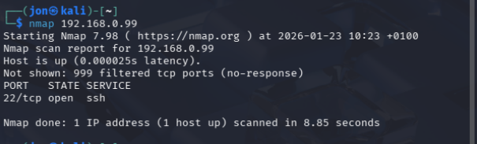

📘 2. Escaneo de un rango de IP
nmap 192.168.1.1-254
- Escanea todas las direcciones IP del rango 192.168.1.1 a 192.168.1.254.
┌──(jon㉿kali)-[~]
└─$ nmap 192.168.0.1-254
Starting Nmap 7.98 ( https://nmap.org ) at 2026-01-23 10:24 +0100
Warning: 192.168.0.61 giving up on port because retransmission cap hit (10).
Nmap scan report for 192.168.0.1
Host is up (0.00063s latency).
Not shown: 995 closed tcp ports (reset)
PORT STATE SERVICE
21/tcp filtered ftp
22/tcp filtered ssh
23/tcp filtered telnet
53/tcp filtered domain
80/tcp filtered http
MAC Address: 00:A0:26:D2:68:9A (Teldat)

Nmap scan report for 192.168.0.5
Host is up (0.00098s latency).
Not shown: 990 closed tcp ports (reset)
PORT STATE SERVICE
21/tcp open ftp
23/tcp open telnet
80/tcp open http
139/tcp open netbios-ssn
514/tcp open shell
515/tcp open printer
631/tcp open ipp
7443/tcp open oracleas-https
8080/tcp open http-proxy
9100/tcp open jetdirect
MAC Address: 00:26:73:99:57:8C (Ricoh Company)

Nmap scan report for 192.168.0.21
Host is up (0.39s latency).
All 1000 scanned ports on 192.168.0.21 are in ignored states.
Not shown: 859 closed tcp ports (reset), 141 filtered tcp ports (no-response)
MAC Address: A6:A3:F7:73:83:98 (Unknown)

Nmap scan report for 192.168.0.23
Host is up (0.00061s latency).
Not shown: 999 filtered tcp ports (no-response)
PORT STATE SERVICE
7070/tcp open realserver
MAC Address: D8:43:AE:44:E2:2F (Micro-Star Intl)

Nmap scan report for 192.168.0.24
Host is up (0.00061s latency).
Not shown: 998 filtered tcp ports (no-response)
PORT STATE SERVICE
5357/tcp open wsdapi
7070/tcp open realserver
MAC Address: 6C:3B:E5:1E:A8:2C (Hewlett Packard)

Nmap scan report for 192.168.0.25
Host is up (0.0012s latency).
Not shown: 993 closed tcp ports (reset)
PORT STATE SERVICE
80/tcp open http
443/tcp open https
554/tcp open rtsp
1935/tcp open rtmp
6001/tcp open X11:1
8000/tcp open http-alt
9000/tcp open cslistener
MAC Address: EC:71:DB:A7:4B:40 (Reolink Innovation Limited)

Nmap scan report for 192.168.0.26
Host is up (0.0065s latency).
Not shown: 997 filtered tcp ports (no-response)
PORT STATE SERVICE
80/tcp open http
443/tcp open https
3306/tcp open mysql
MAC Address: 68:EC:C5:04:D3:C8 (Intel Corporate)

Nmap scan report for 192.168.0.27
Host is up (0.00092s latency).
Not shown: 995 filtered tcp ports (no-response)
PORT STATE SERVICE
80/tcp open http
443/tcp open https
3306/tcp open mysql
5357/tcp open wsdapi
7070/tcp open realserver
MAC Address: 08:2E:5F:2F:F1:74 (Hewlett Packard)

Nmap scan report for 192.168.0.29
Host is up (0.021s latency).
Not shown: 998 filtered tcp ports (no-response)
PORT STATE SERVICE
902/tcp open iss-realsecure
912/tcp open apex-mesh
MAC Address: 14:13:33:E5:20:C1 (AzureWave Technology)

Nmap scan report for 192.168.0.30
Host is up (0.0010s latency).
Not shown: 999 filtered tcp ports (no-response)
PORT STATE SERVICE
7070/tcp open realserver
MAC Address: D8:43:AE:44:E2:70 (Micro-Star Intl)

Nmap scan report for 192.168.0.34
Host is up (0.0019s latency).
Not shown: 995 filtered tcp ports (no-response)
PORT STATE SERVICE
135/tcp open msrpc
139/tcp open netbios-ssn
445/tcp open microsoft-ds
5357/tcp open wsdapi
7070/tcp open realserver
MAC Address: 78:AC:C0:BD:A1:59 (Hewlett Packard)

Nmap scan report for 192.168.0.35
Host is up (0.0073s latency).
Not shown: 999 filtered tcp ports (no-response)
PORT STATE SERVICE
3389/tcp open ms-wbt-server
MAC Address: 50:2E:91:98:DB:00 (Unknown)

Nmap scan report for 192.168.0.36
Host is up (0.0011s latency).
Not shown: 999 filtered tcp ports (no-response)
PORT STATE SERVICE
7070/tcp open realserver
MAC Address: D8:43:AE:44:E2:29 (Micro-Star Intl)

Nmap scan report for 192.168.0.38
Host is up (0.062s latency).
Not shown: 998 closed tcp ports (reset)
PORT STATE SERVICE
3323/tcp filtered active-net
6007/tcp filtered X11:7
MAC Address: F4:1A:9C:16:51:18 (Xiaomi Communications)

Nmap scan report for 192.168.0.39
Host is up (0.41s latency).
All 1000 scanned ports on 192.168.0.39 are in ignored states.
Not shown: 1000 closed tcp ports (reset)
MAC Address: 4A:FD:90:1D:B4:5C (Unknown)

Nmap scan report for 192.168.0.40
Host is up (0.0011s latency).
All 1000 scanned ports on 192.168.0.40 are in ignored states.
Not shown: 504 filtered tcp ports (no-response), 496 closed tcp ports (reset)
MAC Address: 08:00:27:82:D1:0D (Oracle VirtualBox virtual NIC)

Nmap scan report for 192.168.0.44
Host is up (0.25s latency).
Not shown: 999 closed tcp ports (reset)
PORT STATE SERVICE
6100/tcp open synchronet-db
MAC Address: BE:69:CA:CF:24:7C (Unknown)

Nmap scan report for 192.168.0.46
Host is up (0.0014s latency).
Not shown: 996 filtered tcp ports (no-response)
PORT STATE SERVICE
135/tcp open msrpc
139/tcp open netbios-ssn
445/tcp open microsoft-ds
5357/tcp open wsdapi
MAC Address: 00:D8:61:86:47:60 (Micro-Star Intl)

Nmap scan report for 192.168.0.48
Host is up (0.0011s latency).
Not shown: 997 filtered tcp ports (no-response)
PORT STATE SERVICE
135/tcp open msrpc
2179/tcp open vmrdp
7070/tcp open realserver
MAC Address: DC:4A:3E:7C:25:3E (Hewlett Packard)

Nmap scan report for 192.168.0.49
Host is up (0.26s latency).
All 1000 scanned ports on 192.168.0.49 are in ignored states.
Not shown: 1000 closed tcp ports (reset)
MAC Address: 6E:28:0D:F0:84:3D (Unknown)

Nmap scan report for 192.168.0.51
Host is up (0.0015s latency).
Not shown: 995 filtered tcp ports (no-response)
PORT STATE SERVICE
135/tcp open msrpc
139/tcp open netbios-ssn
445/tcp open microsoft-ds
5357/tcp open wsdapi
7070/tcp open realserver
MAC Address: DC:4A:3E:8D:C1:B5 (Hewlett Packard)

Nmap scan report for 192.168.0.52
Host is up (0.0021s latency).
Not shown: 999 filtered tcp ports (no-response)
PORT STATE SERVICE
22/tcp closed ssh
MAC Address: 08:00:27:BA:D7:9A (Oracle VirtualBox virtual NIC)

Nmap scan report for 192.168.0.53
Host is up (0.039s latency).
Not shown: 999 filtered tcp ports (no-response)
PORT STATE SERVICE
8080/tcp closed http-proxy
MAC Address: 08:00:27:E4:0D:E7 (Oracle VirtualBox virtual NIC)

Nmap scan report for 192.168.0.58
Host is up (0.29s latency).
All 1000 scanned ports on 192.168.0.58 are in ignored states.
Not shown: 1000 closed tcp ports (reset)
MAC Address: D6:A8:85:36:52:B2 (Unknown)

Nmap scan report for 192.168.0.59
Host is up (0.90s latency).
All 1000 scanned ports on 192.168.0.59 are in ignored states.
Not shown: 1000 filtered tcp ports (no-response)
MAC Address: 9E:89:E4:DD:A1:04 (Unknown)

Nmap scan report for 192.168.0.61
Host is up (0.19s latency).
Not shown: 952 closed tcp ports (reset), 46 filtered tcp ports (no-response)
PORT STATE SERVICE
49152/tcp open unknown
62078/tcp open iphone-sync
MAC Address: E6:98:DB:5A:0C:62 (Unknown)

Nmap scan report for 192.168.0.62
Host is up (0.0063s latency).
All 1000 scanned ports on 192.168.0.62 are in ignored states.
Not shown: 1000 closed tcp ports (reset)
MAC Address: FC:02:96:44:3B:EC (Xiaomi Communications)

Nmap scan report for 192.168.0.63
Host is up.
All 1000 scanned ports on 192.168.0.63 are in ignored states.
Not shown: 1000 filtered tcp ports (no-response)
MAC Address: A4:42:3B:70:1F:57 (Intel Corporate)

Nmap scan report for 192.168.0.64
Host is up (0.0019s latency).
Not shown: 999 closed tcp ports (reset)
PORT STATE SERVICE
80/tcp open http
MAC Address: 00:1D:94:0D:B5:3A (Climax Technology)

Nmap scan report for 192.168.0.65
Host is up (0.33s latency).
All 1000 scanned ports on 192.168.0.65 are in ignored states.
Not shown: 1000 closed tcp ports (reset)
MAC Address: 66:19:96:D0:61:D0 (Unknown)

Nmap scan report for 192.168.0.66
Host is up (0.031s latency).
All 1000 scanned ports on 192.168.0.66 are in ignored states.
Not shown: 1000 filtered tcp ports (no-response)
MAC Address: 00:E0:4C:68:0F:5F (Realtek Semiconductor)

Nmap scan report for 192.168.0.67
Host is up (0.00078s latency).
Not shown: 999 filtered tcp ports (no-response)
PORT STATE SERVICE
7070/tcp open realserver
MAC Address: D8:43:AE:44:E2:25 (Micro-Star Intl)

Nmap scan report for 192.168.0.68
Host is up (0.019s latency).
Not shown: 997 closed tcp ports (reset)
PORT STATE SERVICE
80/tcp open http
554/tcp open rtsp
1935/tcp open rtmp
MAC Address: 08:ED:ED:B5:AA:E6 (Zhejiang Dahua Technology)

Nmap scan report for 192.168.0.69
Host is up (0.0011s latency).
Not shown: 993 closed tcp ports (reset)
PORT STATE SERVICE
80/tcp open http
443/tcp open https
554/tcp open rtsp
1935/tcp open rtmp
6001/tcp open X11:1
8000/tcp open http-alt
9000/tcp open cslistener
MAC Address: EC:71:DB:49:BA:17 (Reolink Innovation Limited)

Nmap scan report for 192.168.0.72
Host is up (0.024s latency).
Not shown: 996 closed tcp ports (reset)
PORT STATE SERVICE
80/tcp open http
554/tcp open rtsp
1935/tcp open rtmp
50003/tcp filtered unknown
MAC Address: 08:ED:ED:B6:33:CC (Zhejiang Dahua Technology)

Nmap scan report for 192.168.0.77
Host is up (0.0012s latency).
Not shown: 995 filtered tcp ports (no-response)
PORT STATE SERVICE
80/tcp open http
443/tcp open https
3306/tcp open mysql
5357/tcp open wsdapi
7070/tcp open realserver
MAC Address: 08:2E:5F:09:05:38 (Hewlett Packard)

Nmap scan report for 192.168.0.78
Host is up (0.0012s latency).
Not shown: 999 closed tcp ports (reset)
PORT STATE SERVICE
22/tcp open ssh
MAC Address: 08:00:27:3A:68:6C (Oracle VirtualBox virtual NIC)

Nmap scan report for 192.168.0.79
Host is up (0.0029s latency).
Not shown: 977 closed tcp ports (reset)
PORT STATE SERVICE
21/tcp open ftp
22/tcp open ssh
23/tcp open telnet
25/tcp open smtp
53/tcp open domain
80/tcp open http
111/tcp open rpcbind
139/tcp open netbios-ssn
445/tcp open microsoft-ds
512/tcp open exec
513/tcp open login
514/tcp open shell
1099/tcp open rmiregistry
1524/tcp open ingreslock
2049/tcp open nfs
2121/tcp open ccproxy-ftp
3306/tcp open mysql
5432/tcp open postgresql
5900/tcp open vnc
6000/tcp open X11
6667/tcp open irc
8009/tcp open ajp13
8180/tcp open unknown
MAC Address: 08:00:27:91:4F:C6 (Oracle VirtualBox virtual NIC)

Nmap scan report for 192.168.0.81
Host is up (0.00099s latency).
Not shown: 995 filtered tcp ports (no-response)
PORT STATE SERVICE
80/tcp open http
443/tcp open https
3306/tcp open mysql
5357/tcp open wsdapi
7070/tcp open realserver
MAC Address: 24:BE:05:21:18:3B (Hewlett Packard)

Nmap scan report for 192.168.0.84
Host is up (0.00096s latency).
Not shown: 999 filtered tcp ports (no-response)
PORT STATE SERVICE
7070/tcp open realserver
MAC Address: D8:43:AE:44:E1:D8 (Micro-Star Intl)

Nmap scan report for 192.168.0.88
Host is up (0.00092s latency).
Not shown: 999 filtered tcp ports (no-response)
PORT STATE SERVICE
7070/tcp open realserver
MAC Address: D8:43:AE:44:E2:63 (Micro-Star Intl)

Nmap scan report for 192.168.0.89
Host is up (0.00064s latency).
Not shown: 998 closed tcp ports (reset)
PORT STATE SERVICE
80/tcp open http
443/tcp open https
MAC Address: C0:56:27:EB:B6:7F (Belkin International)

Nmap scan report for 192.168.0.90
Host is up (0.0010s latency).
Not shown: 997 closed tcp ports (reset)
PORT STATE SERVICE
22/tcp open ssh
80/tcp open http
443/tcp open https
MAC Address: A4:97:33:4E:9F:C4 (Askey Computer)

Nmap scan report for 192.168.0.93
Host is up (0.0018s latency).
All 1000 scanned ports on 192.168.0.93 are in ignored states.
Not shown: 1000 filtered tcp ports (no-response)
MAC Address: 6C:62:6D:87:2A:2C (Micro-Star INT'L)

Nmap scan report for 192.168.0.95
Host is up (0.11s latency).
All 1000 scanned ports on 192.168.0.95 are in ignored states.
Not shown: 1000 closed tcp ports (reset)
MAC Address: 38:65:04:B0:91:F4 (Honor Device)

Nmap scan report for 192.168.0.96
Host is up (0.057s latency).
Not shown: 998 filtered tcp ports (no-response)
PORT STATE SERVICE
80/tcp open http
443/tcp open https
MAC Address: 50:84:92:24:3C:45 (Intel Corporate)

Nmap scan report for 192.168.0.97
Host is up (0.00074s latency).
Not shown: 999 filtered tcp ports (no-response)
PORT STATE SERVICE
7070/tcp open realserver
MAC Address: D8:43:AE:44:E2:72 (Micro-Star Intl)

Nmap scan report for 192.168.0.108
Host is up (0.00031s latency).
All 1000 scanned ports on 192.168.0.108 are in ignored states.
Not shown: 1000 filtered tcp ports (no-response)
MAC Address: 5C:60:BA:B8:2E:D5 (HP)

Nmap scan report for 192.168.0.109
Host is up.
All 1000 scanned ports on 192.168.0.109 are in ignored states.
Not shown: 1000 filtered tcp ports (no-response)
MAC Address: 14:18:C3:BF:08:B0 (Intel Corporate)

Nmap scan report for 192.168.0.110
Host is up (0.0027s latency).
Not shown: 998 filtered tcp ports (no-response)
PORT STATE SERVICE
22/tcp open ssh
8080/tcp closed http-proxy
MAC Address: 08:00:27:D1:F8:5D (Oracle VirtualBox virtual NIC)

Nmap scan report for 192.168.0.111
Host is up (0.0077s latency).
Not shown: 996 filtered tcp ports (no-response)
PORT STATE SERVICE
80/tcp open http
443/tcp open https
2968/tcp open enpp
3306/tcp open mysql
MAC Address: A0:02:A5:69:81:DD (Intel Corporate)

Nmap scan report for 192.168.0.112
Host is up (0.00071s latency).
Not shown: 998 filtered tcp ports (no-response)
PORT STATE SERVICE
5357/tcp open wsdapi
7070/tcp open realserver
MAC Address: 78:AC:C0:C2:C6:66 (Hewlett Packard)

Nmap scan report for 192.168.0.113
Host is up (0.0013s latency).
Not shown: 998 filtered tcp ports (no-response)
PORT STATE SERVICE
22/tcp closed ssh
8080/tcp closed http-proxy
MAC Address: 08:00:27:82:39:62 (Oracle VirtualBox virtual NIC)

Nmap scan report for 192.168.0.116
Host is up (0.066s latency).
All 1000 scanned ports on 192.168.0.116 are in ignored states.
Not shown: 1000 closed tcp ports (reset)
MAC Address: DA:3A:EC:84:9F:88 (Unknown)

Nmap scan report for 192.168.0.117
Host is up (0.0013s latency).
All 1000 scanned ports on 192.168.0.117 are in ignored states.
Not shown: 1000 closed tcp ports (reset)
MAC Address: 08:00:27:63:E8:C5 (Oracle VirtualBox virtual NIC)

Nmap scan report for 192.168.0.119
Host is up (0.0047s latency).
Not shown: 992 filtered tcp ports (no-response)
PORT STATE SERVICE
1025/tcp closed NFS-or-IIS
3367/tcp open satvid-datalnk
5000/tcp closed upnp
6000/tcp closed X11
7000/tcp open afs3-fileserver
8086/tcp closed d-s-n
9080/tcp closed glrpc
20000/tcp closed dnp
MAC Address: C0:E5:DA:EC:5C:1E (Qingdao Intelligent&Precise Electronics)

Nmap scan report for 192.168.0.121
Host is up (0.0012s latency).
Not shown: 998 closed tcp ports (reset)
PORT STATE SERVICE
22/tcp open ssh
80/tcp open http
MAC Address: 08:00:27:3D:10:E5 (Oracle VirtualBox virtual NIC)

Nmap scan report for 192.168.0.122
Host is up (0.025s latency).
All 1000 scanned ports on 192.168.0.122 are in ignored states.
Not shown: 1000 filtered tcp ports (no-response)
MAC Address: D8:A3:5C:D8:F8:6C (Samsung Electronics)

Nmap scan report for 192.168.0.125
Host is up (0.0012s latency).
Not shown: 993 filtered tcp ports (no-response)
PORT STATE SERVICE
135/tcp open msrpc
139/tcp open netbios-ssn
445/tcp open microsoft-ds
5357/tcp open wsdapi
7070/tcp open realserver
8000/tcp open http-alt
8001/tcp open vcom-tunnel
MAC Address: 2C:41:38:AC:7D:1C (Hewlett Packard)

Nmap scan report for 192.168.0.127
Host is up (0.0011s latency).
Not shown: 995 filtered tcp ports (no-response)
PORT STATE SERVICE
135/tcp open msrpc
139/tcp open netbios-ssn
445/tcp open microsoft-ds
5357/tcp open wsdapi
7070/tcp open realserver
MAC Address: 98:EE:CB:46:94:F7 (Wistron Infocomm (Zhongshan))

Nmap scan report for 192.168.0.128
Host is up (0.00089s latency).
Not shown: 999 filtered tcp ports (no-response)
PORT STATE SERVICE
7070/tcp open realserver
MAC Address: 18:60:24:E9:3B:2A (Hewlett Packard)

Nmap scan report for 192.168.0.130
Host is up (0.0012s latency).
All 1000 scanned ports on 192.168.0.130 are in ignored states.
Not shown: 1000 closed tcp ports (reset)
MAC Address: 08:00:27:FC:60:1C (Oracle VirtualBox virtual NIC)

Nmap scan report for 192.168.0.131
Host is up (0.0042s latency).
All 1000 scanned ports on 192.168.0.131 are in ignored states.
Not shown: 1000 filtered tcp ports (no-response)
MAC Address: 8C:B0:E9:E1:90:38 (Samsung Electronics.)

Nmap scan report for 192.168.0.133
Host is up (0.00077s latency).
Not shown: 998 filtered tcp ports (no-response)
PORT STATE SERVICE
5357/tcp open wsdapi
7070/tcp open realserver
MAC Address: 08:2E:5F:09:05:51 (Hewlett Packard)

Nmap scan report for 192.168.0.209
Host is up (0.0014s latency).
Not shown: 998 closed tcp ports (reset)
PORT STATE SERVICE
22/tcp open ssh
2022/tcp open down
MAC Address: 00:0C:29:13:85:B3 (VMware)

Nmap scan report for 192.168.0.219
Host is up (0.00074s latency).
Not shown: 998 closed tcp ports (reset)
PORT STATE SERVICE
5000/tcp open upnp
7000/tcp open afs3-fileserver
MAC Address: D0:37:45:76:99:E3 (TP-Link Technologies)

Nmap scan report for 192.168.0.99
Host is up (0.000035s latency).
Not shown: 999 filtered tcp ports (no-response)
PORT STATE SERVICE
22/tcp open ssh

Nmap done: 254 IP addresses (67 hosts up) scanned in 3506.34 seconds

📘 3. Escaneo de varias direcciones IP específicas
nmap 192.168.1.1 192.168.1.4 192.168.1.43
- Escanea múltiples IP individuales especificadas manualmente.
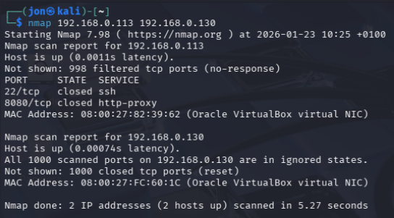

📘 4. Escaneo de puertos específicos
nmap -p 1042 192.168.1.143
- Escanea solo el puerto 1042 en la IP dada.
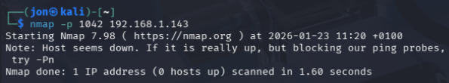

📘 5. Escaneo de puertos UDP
nmap -sU -p 7 11 15 18 19 20 21 22 51 143 514 8080 192.168.1.143
- Escaneo en modo UDP de puertos específicos.
- El parámetro -sU indica que se trata de un escaneo de puertos UDP.
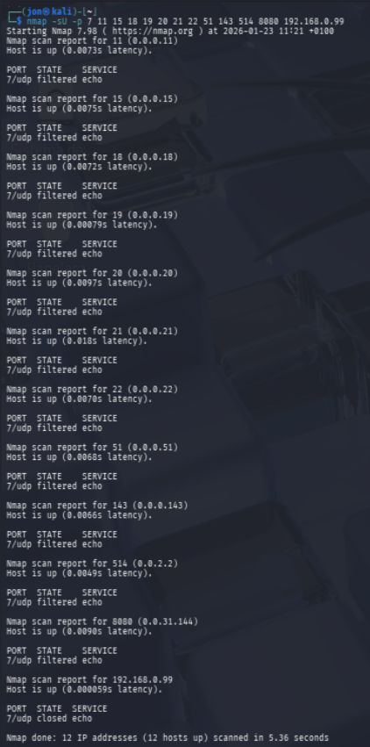

📘 6. Escaneo del sistema operativo
nmap -O -osscan-guess localhost
- Detecta el sistema operativo del host local.
- El parámetro --osscan-guess permite adivinar el sistema si no se reconoce con certeza.
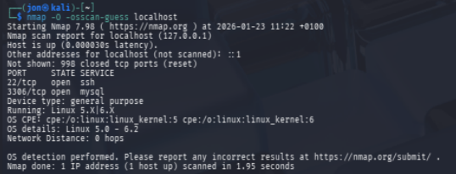

📘 7. Mostrar versión de los servicios
nmap -sV -version-all localhost
- Muestra la versión de los servicios detectados en el host local.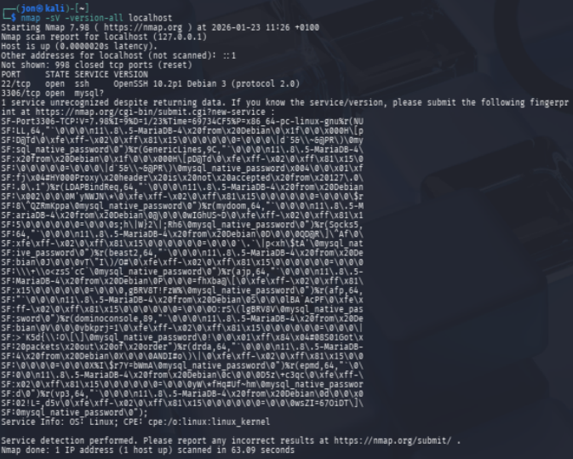

📘 8. Mostrar información del sistema Nmap instalado
nmap -SV --version-1ll localhost
- Posible errata tipográfica, probablemente se refiere a:
nmap -sV --version-intensity 9 localhost
┌──(jon㉿kali)-[~]
└─$ nmap -sV --version-intensity 9 localhost
Starting Nmap 7.98 ( https://nmap.org ) at 2026-01-23 11:39 +0100
Nmap scan report for localhost (127.0.0.1)
Host is up (0.0000020s latency).
Other addresses for localhost (not scanned): ::1
Not shown: 998 closed tcp ports (reset)
PORT STATE SERVICE VERSION
22/tcp open ssh OpenSSH 10.2p1 Debian 3 (protocol 2.0)
3306/tcp open mysql?
1 service unrecognized despite returning data. If you know the service/version, please submit the following fingerprint at https://nmap.org/cgi-bin/submit.cgi?new-service :
SF-Port3306-TCP:V=7.98%I=9%D=1/23%Time=69734FED%P=x86_64-pc-linux-gnu%r(NU
SF:LL,64,"`\0\0\0\n11\.8\.5-MariaDB-4\x20from\x20Debian\0\x1f\0\0\0T-\"aDn
SF:~Q\0\xfe\xff-\x02\0\xff\x81\x15\0\0\0\0\0\0=\0\0\0XD\.XPf5pV>rF\0mysql_
SF:native_password\0")%r(GenericLines,9C,"`\0\0\0\n11\.8\.5-MariaDB-4\x20f
SF:rom\x20Debian\0\x1f\0\0\0T-\"aDn~Q\0\xfe\xff-\x02\0\xff\x81\x15\0\0\0\0
SF:\0\0=\0\0\0XD\.XPf5pV>rF\0mysql_native_password\x004\0\0\x01\xffj\x04#H
SF:Y000Proxy\x20header\x20is\x20not\x20accepted\x20from\x20127\.0\.0\.1")%
SF:r(LDAPBindReq,64,"`\0\0\0\n11\.8\.5-MariaDB-4\x20from\x20Debian\x002\0\
SF:0\0q}Bo\*~_@\0\xfe\xff-\x02\0\xff\x81\x15\0\0\0\0\0\0=\0\0\0aJ/H_\(CXsY
SF:C&\0mysql_native_password\0")%r(mydoom,64,"`\0\0\0\n11\.8\.5-MariaDB-4\
SF:x20from\x20Debian\0@\0\0\0;LLx;Y\.y\0\xfe\xff-\x02\0\xff\x81\x15\0\0\0\
SF:0\0\0=\0\0\0;X\+k\[gq\$\[}%=\0mysql_native_password\0")%r(Socks5,64,"`\
SF:0\0\0\n11\.8\.5-MariaDB-4\x20from\x20Debian\0D\0\0\0wm;\|#5~\?\0\xfe\xf
SF:f-\x02\0\xff\x81\x15\0\0\0\0\0\0=\0\0\0\[0y47U\*k_\|rG\0mysql_native_pa
SF:ssword\0")%r(beast2,64,"`\0\0\0\n11\.8\.5-MariaDB-4\x20from\x20Debian\0
SF:J\0\0\0zTtk>1y1\0\xfe\xff-\x02\0\xff\x81\x15\0\0\0\0\0\0=\0\0\0\(p\"QU4
SF:FC\[!0m\0mysql_native_password\0")%r(ajp,64,"`\0\0\0\n11\.8\.5-MariaDB-
SF:4\x20from\x20Debian\0P\0\0\0\)\[pD@Uk:\0\xfe\xff-\x02\0\xff\x81\x15\0\0
SF:\0\0\0\0=\0\0\0}\*SEAVmA<I;\)\0mysql_native_password\0")%r(afp,64,"`\0\
SF:0\0\n11\.8\.5-MariaDB-4\x20from\x20Debian\0S\0\0\0S}>\[2\$\^\.\0\xfe\xf
SF:f-\x02\0\xff\x81\x15\0\0\0\0\0\0=\0\0\0iIotx~3\|:LM}\0mysql_native_pass
SF:word\0")%r(dominoconsole,89,"`\0\0\0\n11\.8\.5-MariaDB-4\x20from\x20Deb
SF:ian\0V\0\0\0puy\"70,\)\0\xfe\xff-\x02\0\xff\x81\x15\0\0\0\0\0\0=\0\0\0\
SF:)3bwN\^o6ZE\*C\0mysql_native_password\0!\0\0\x01\xff\x84\x04#08S01Got\x
SF:20packets\x20out\x20of\x20order")%r(drda,64,"`\0\0\0\n11\.8\.5-MariaDB-
SF:4\x20from\x20Debian\0X\0\0\0RXG9\(Zm9\0\xfe\xff-\x02\0\xff\x81\x15\0\0\
SF:0\0\0\0=\0\0\0oHVW6C0c'6wv\0mysql_native_password\0")%r(epmd,64,"`\0\0\
SF:0\n11\.8\.5-MariaDB-4\x20from\x20Debian\0c\0\0\x006~>TnNy7\0\xfe\xff-\x
SF:02\0\xff\x81\x15\0\0\0\0\0\0=\0\0\0C,Q3IVS!G!o\.\0mysql_native_password
SF:\0")%r(vp3,64,"`\0\0\0\n11\.8\.5-MariaDB-4\x20from\x20Debian\0d\0\0\x00
SF:2C80\(v>o\0\xfe\xff-\x02\0\xff\x81\x15\0\0\0\0\0\0=\0\0\x005W;\\\?feFo\
SF:|@k\0mysql_native_password\0");
Service Info: OS: Linux; CPE: cpe:/o:linux:linux_kernel

Service detection performed. Please report any incorrect results at https://nmap.org/submit/ .
Nmap done: 1 IP address (1 host up) scanned in 63.04 seconds

📘 9. Ver interfaces de red
nmap --iflist localhost
- Muestra todas las interfaces de red y rutas de la máquina local.
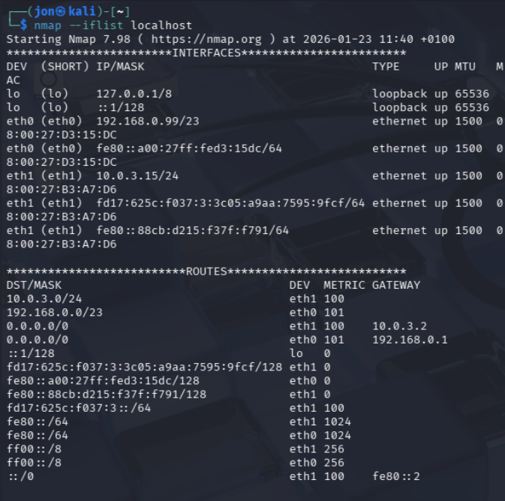

📘 10. Enviar paquetes TCP ACK
nmap -sA 192.168.1.143
- Escanea con paquetes TCP ACK para detectar hosts activos incluso tras firewall.
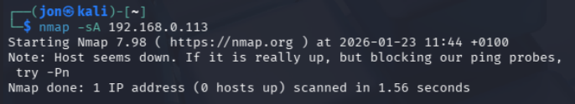

📘 11. Actividad propuesta 1.9: Zenmap GUI para Nmap
🧩Instrucciones del ejercicio:
Instala Zenmap (entorno gráfico para Nmap) en tu máquina Windows.
Investiga y explica la utilidad de las diferentes pestañas que ofrece la aplicación.

📘 12. Otros comandos avanzados (mencionados en la imagen):
- Detección de DNS inverso:
nmap -sL 192.168.43.0/24
- Escaneo de versión con --version-trace
- Exclusión de host:
nmap 192.168.1.0/24 --exclude 192.168.1.1

